**Appendix D: Analysis of the influence of** *θY* **on the reconstructed shape**

The principles of shape reconstruction, under the conditions of *θY*=0 and *θY*≠0, are shown in Figures 1(a) and 1(b).

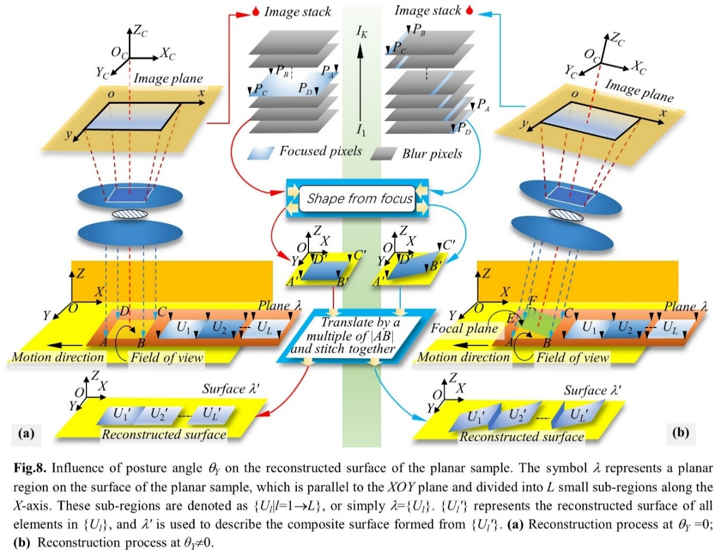

**Figure 1.** Influence of posture angle *θY* on the reconstructed surface of the planar sample. The symbol *λ* represents a planar region on the surface of the planar sample, which is parallel to the *XOY* plane and divided into *L* small sub-regions along the *X*-axis. These sub-regions are denoted as {*Ul*|*l*=1→*L*}, or simply *λ*={*Ul*}. {*Ul′*} represents the reconstructed surface of all elements in {*Ul*}, and *λ′* is used to describe the composite surface formed from {*Ul′*}. **(a)** Reconstruction process at *θY* =0; **(b)** Reconstruction process at *θY*≠0.

In Figure 1(a), the field of view is the area enclosed by the four vertices *A*, *B*, *C*, and *D*, known as *SABCD*. Since the image sensor is a rectangular array, *SABCD* represents a rectangular plane area with its normal parallel to the optical axis. As the plane area *λ* is translated along the *X*-axis, its local regions enter the field of view *SABCD*. Depending on the size of *SABCD*, *λ* is divided into *L* rectangular sub-areas {*Ul*}, which are arranged along the *X*-axis and are the same size as *SABCD*. *U*1→*UL* sequentially enters the field of view and fills *SABCD*. When they are in the field of view *SABCD*, they are denoted as {*Ul*. *SABCD*|*l*=1→*L*}, and all units in {*Ul*. *SABCD*} completely coincide with *SABCD*. We reconstruct the units in {*Ul*. *SABCD*}, and the reconstruction process is outlined by the following formula.

(D_1)

Where *Recon*(·) represents the reconstruction process outlined in Sec. 2.3. Points *A′*, *B′*, *C′*, and *D′* are the reconstructed points corresponding to vertices *A*, *B*, *C*, and *D*. *Ul′*. *SA′B′C′D′* denotes the region generated after reconstructing *Ul*. *SABCD*. Since the units in {*Ul*. *SABCD*} perfectly coincide, and assuming there are no differences in the properties of the units (such as texture), all units in {*Ul′*. *SA′B′C′D′*} also perfectly coincide in *O-XYZ*. The next step is to translate and expand the units in {*Ul′*. *SA′B′C′D′*} along the *X*-axis and recover the result to form {*Ul′*}. {*Ul′*} is the reconstruction result of {*Ul*}, and this process is described by the following equation.

(D_2)

Where *Unfold.X*(·) refers to the method of unfolding the surface along the *X*-axis, and *λ′* denotes the surface composed of {*Ul′*}. *Ul* is translated along the *X*-axis by a distance of (*l*-1)×|*AB*| to obtain *Ul*. *SABCD*. Similarly, *Ul′*. *SA′B′C′D′* is translated in the opposite direction along the *X*-axis by a distance of (*l*-1)×|*AB*| to obtain *Ul′*. Since *SABCD* is parallel to the *XOY* plane, the image points of all object points in {*Ul*.*SABCD*} are located within the same image frame, meaning they share the same *z*-coordinate. According to Eq. (D_1), all reconstructed points in {*Ul′*. *SA′B′C′D′*} also possess the same *Z*-coordinate, indicating that all units in {*Ul′*. *SA′B′C′D′*} not only overlap but are also parallel to the *XOY* plane. The surface *λ′* generated by unfolding along the X-axis must be a planar area.

In Figure 1(b), *U*1→*UL* also shifts along the *X*-axis into *SABCD* to generate {*Ul*. *SABCD*}, and subsequently, {*Ul′*. *SA′B′C′D′*} is obtained through the reconstruction process. Unlike in Figure 1(a), there is an angle *θY* between the normal vectors of *SABCD* and *SEBCF*. During image acquisition, object points in *SABCD* move along the *Z*-axis through the inclined *SEBCF*. The image points corresponding to these object points may be distributed across different image frames and possess varying *z*-coordinates. Consequently, the reconstructed points in {*Ul′*. *SA′B′C′D′*} may also have different *Z*-coordinates, and their normal vectors are no longer parallel to the *Z*-axis. Applying the method outlined in Eq. (D_2), {*Ul′*. *SA′B′C′D′*} is unfolded to generate {*Ul′*} and *λ′*. The units in {*Ul′*} remain parallel, but their normal vectors are misaligned with the *Z*-axis, resulting in a wavy pattern. As a result, *λ′* is no longer a planar region but instead exhibits a wavy structure surface.